**What you need to bring to your HEAP Appointment:**

**U.S. Citizenship or U.S. Non-Citizen National Status may be verified using ONE of the following documents:**

* + U.S. Passport
  + Maine Real ID
  + Certificate of Naturalization
  + Certificate of Citizenship
  + U.S. Birth Certificate
  + Tribal enrollment Card
  + Certificate of Degree of Indian Blood
  + Tribal census document
  + Documents on Tribal letterhead signed by a Tribal official

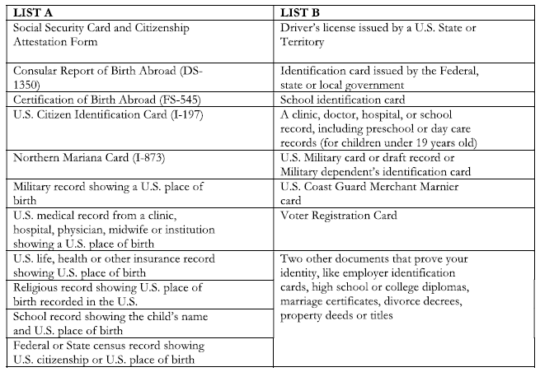

**Applicant must also verify their identity by showing ONE of the following:**

* + Drivers license
  + State issued ID card
  + Passport or passport card
  + SNAP electronic benefit transfer card with photo
  + U.S. Military ID

**If the documentation listed above is unavailable, Two of the following documents are acceptable:** 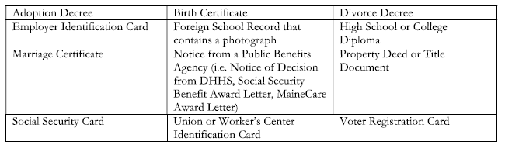

**All household members two years of age of older must provide proof of their Social Security Number (SSN). ONE of the following documents is acceptable provided it contains all nine digits of the Applicant’s SSN and the Household Member’s full name:**

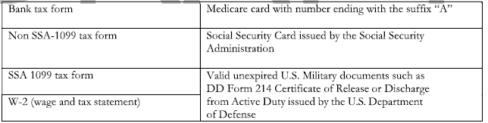

**Other required documentation includes:**

* Current light bill if responsible for paying for lights (even if it is not in your name)
* Proof of all income for entire household for the 3 or 12 months prior to the month of the appointment.
* Fuel vendor name, account number, and name on the account (It must be in a household member's name.)
* Signed Permission to Share Personal Information form sent with appointment letter

**Additional information needed if you RENT:**

* Name, address, and phone number of your landlord
* Current HUD Recertification paperwork
* Rental receipts for the prior 60 days